**PROJECT ON garage parking**

team members:

ARYAN PRATYUSH NAYAK

SWAROOP

NIRLIPTA DAS

BIBEK

AMLAN MISHRA

ABSTRACT:

It is often seen that people who have small garages has a problem of parking their vehicle at the correct place.More than often they park a little bit too far in and collide with the objects present there.To get rid of this problem we have planned a collision avoidance system in the garage which will ensure safe parking of the vehicle by displaying the distance from the object infront of the vehicle. A 'stop' message will be displayed when it's time to stop.

COMPONENTS:

1)An Arduino Board

2)MAX7219 LED Dot Matrix 4 In 1 Display with 5P Line Module:

|  |  |
| --- | --- |
|  | |
|  | |
|  | |
|  | |
| Input Voltage (V) | 5 | |
| LED Colour | Red | |
| LED Display Dimensions (mm) | 32x32x6 (LxWxH) | |
| Weight | 0.125 kg | |
| Dimensions | 13 × 4 × 1 cm | |

3) Ultrasonic Ranging Module HC - SR04

|  |  |
| --- | --- |
| Working Voltage | DC 5 V |
| Working Current | 15mA |
| Max Range | 4m |
| Min Range | 2cm |
| Measuring Angle | 15 degree |
| Dimension | 45x20x15mm |

Schematics :-

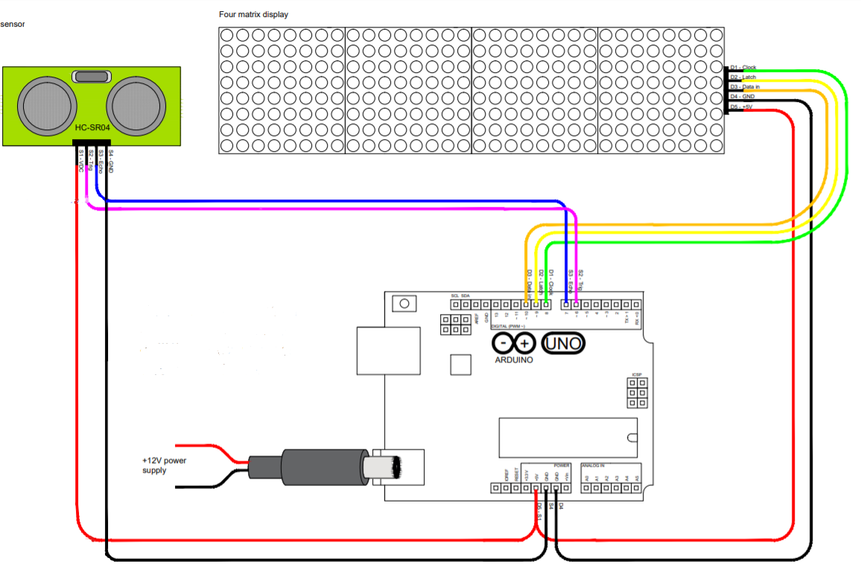

CIRCUIT WORKING PROCEDURE :-